How Does It Work?

A stepper motor is a motor that moves one step at a time, with its step defined by a step angle.

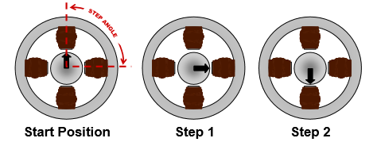

<http://www.microchip.com/stellent/groups/SiteComm_sg/documents/DeviceDoc/en543047.pdf>

The image above represents a stepper motor that requires 4 steps to complete a 360 degrees rotation. This determines the step angle to be 90 degrees.

The main components of a stepper motor are represented in the image below, and they consist of stators, windings(phases), and rotor.

The part that moves, is the rotor, which can be magnetized or not, depending on the type of stepper motor.

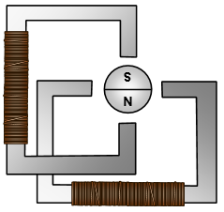

<http://www.microchip.com/stellent/groups/SiteComm_sg/documents/DeviceDoc/en543047.pdf>

By applying a voltage across one of the windings, current will start flowing through it. By using the right-hand rule, the direction of the magnetic flux can be determined. This is represented in the image below.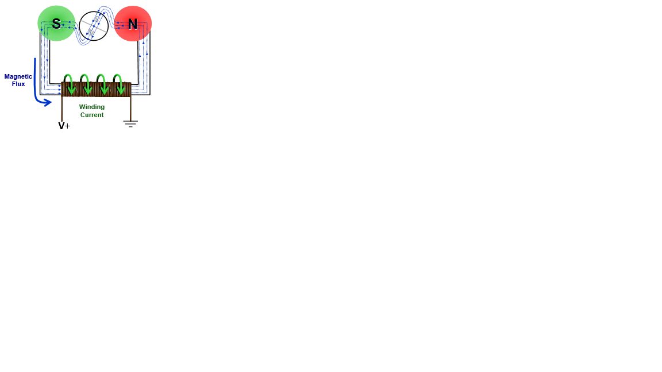

<http://www.microchip.com/stellent/groups/SiteComm_sg/documents/DeviceDoc/en543047.pdf>

The flux will want to travel through the path that has the least resistance. This determines the rotor to change its position to minimize resistance. This is shown in the image below.

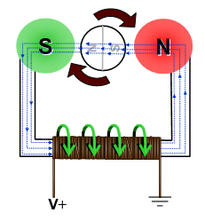<http://www.microchip.com/stellent/groups/SiteComm_sg/documents/DeviceDoc/en543047.pdf>

Types of Stepper Motors

Permanent Magnet Motor

This type of stepper motor has a magnetized rotor. Each winding, will be subdivided into two, to better understand how to motor functions. The image below represents the windings, and how they are distributed inside a stepper motor.

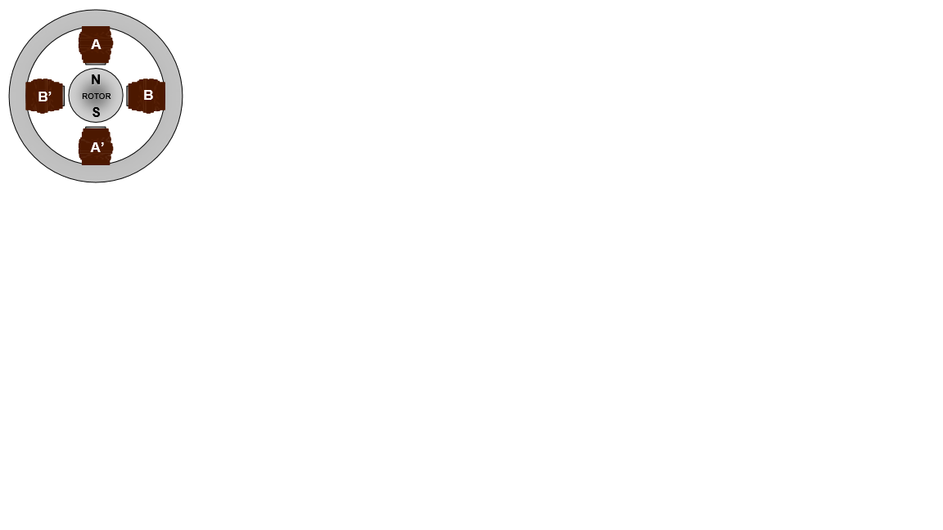 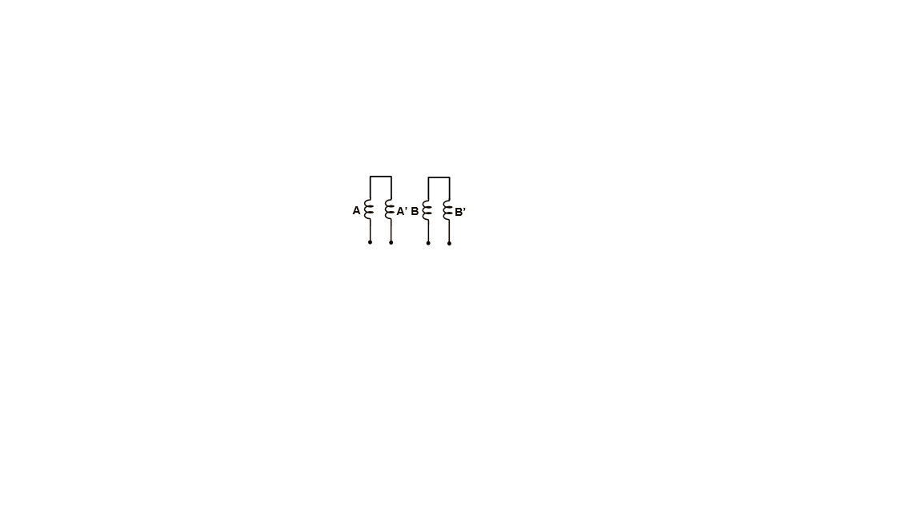

<http://www.microchip.com/stellent/groups/SiteComm_sg/documents/DeviceDoc/en543047.pdf>

The resolution of the motor can be improved in two ways, either by increasing the number of pole pairs in the rotor itself, or by increasing the number of phases as shown below.

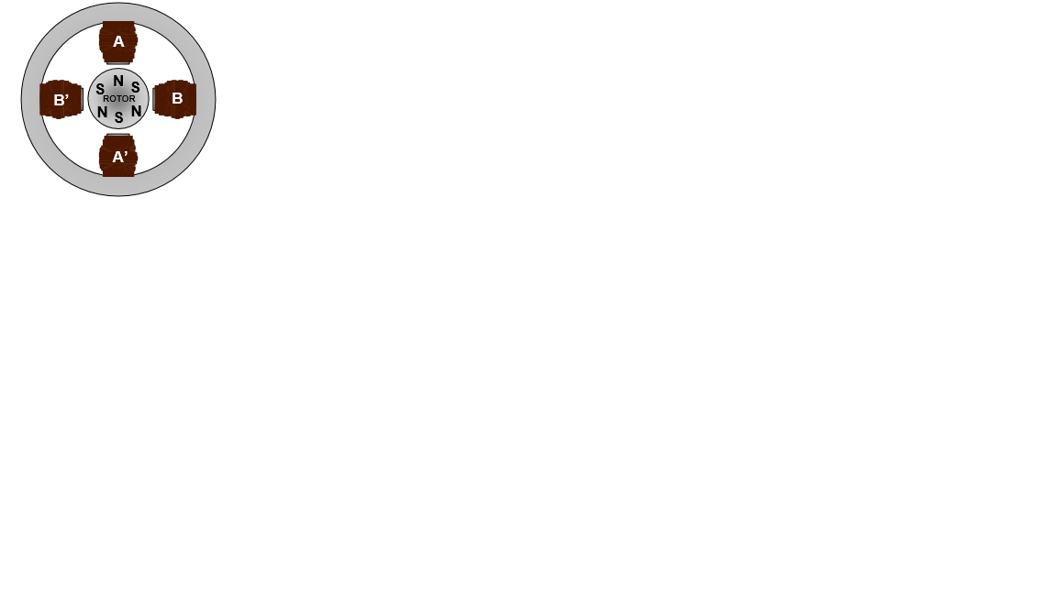 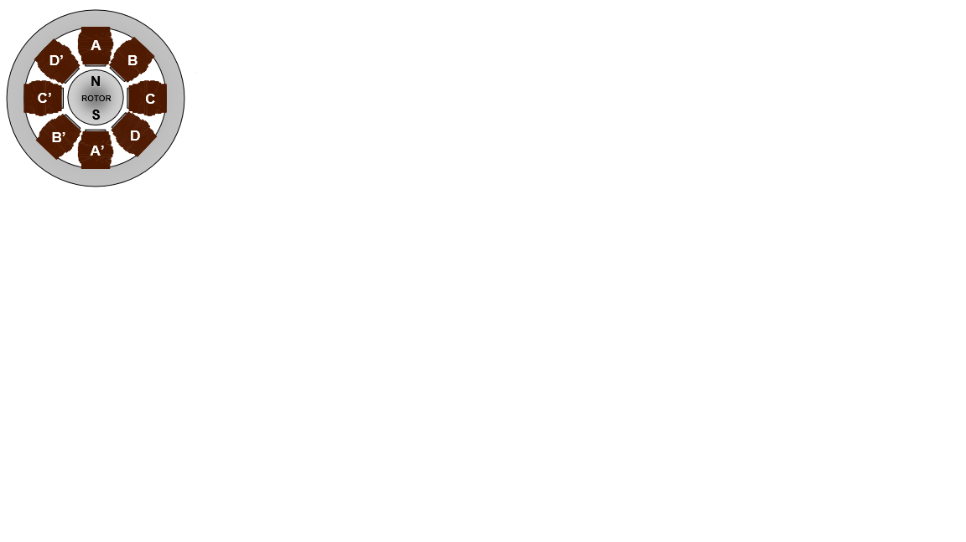

<http://www.microchip.com/stellent/groups/SiteComm_sg/documents/DeviceDoc/en543047.pdf>

To rotate the motor, simply apply a voltage across the windings in a sequence. A full rotation is shown in the images below, with the corresponding phase energized.

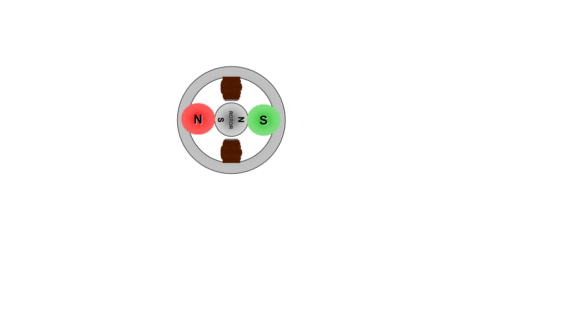 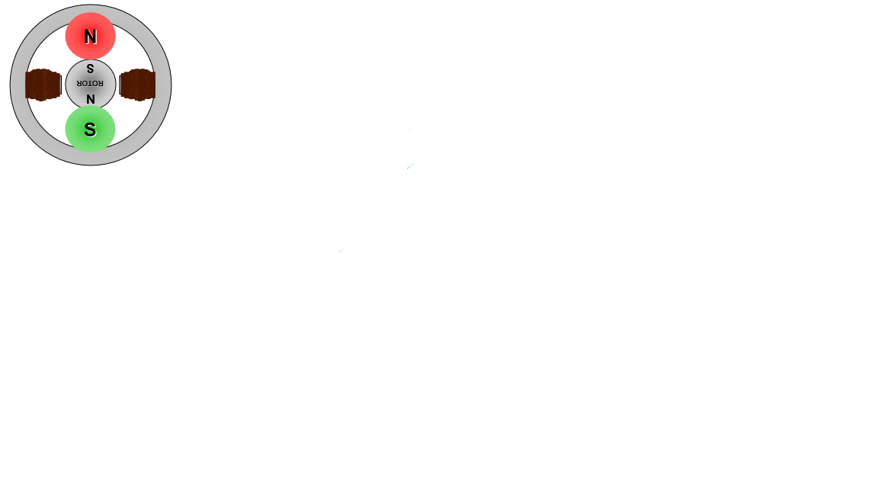 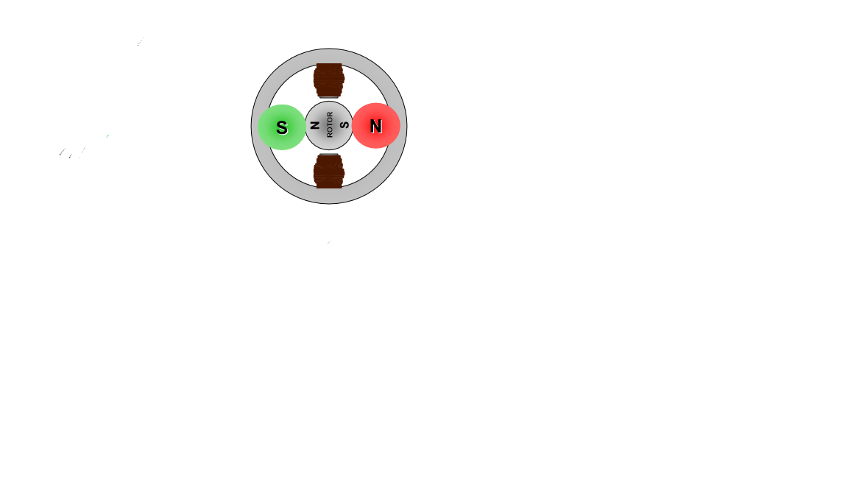 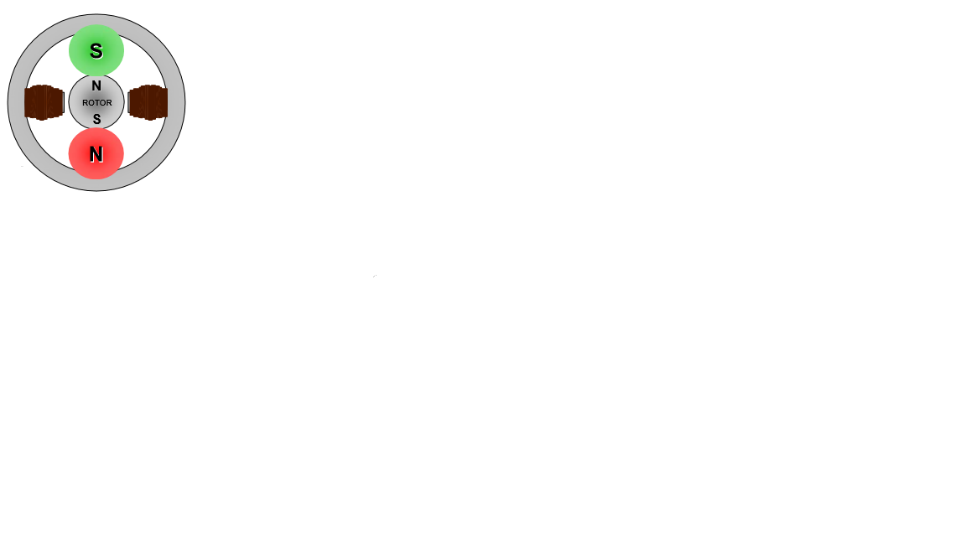

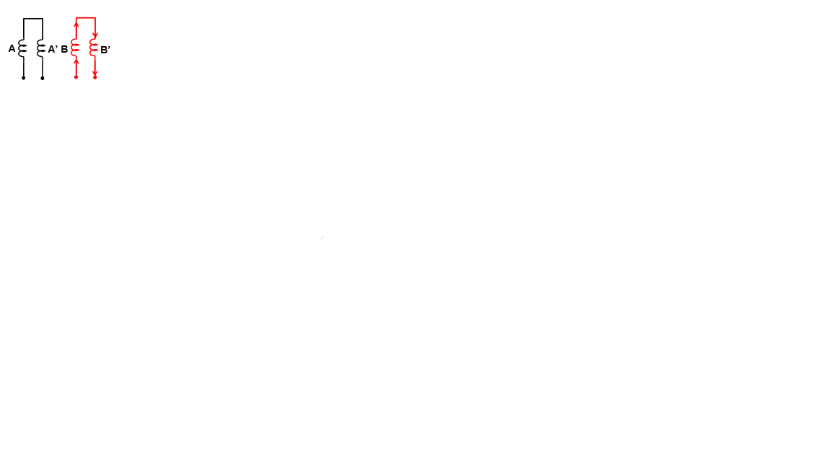 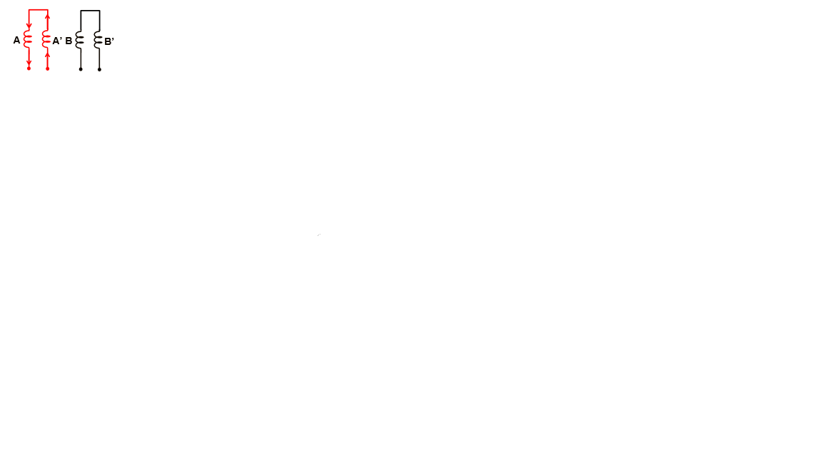 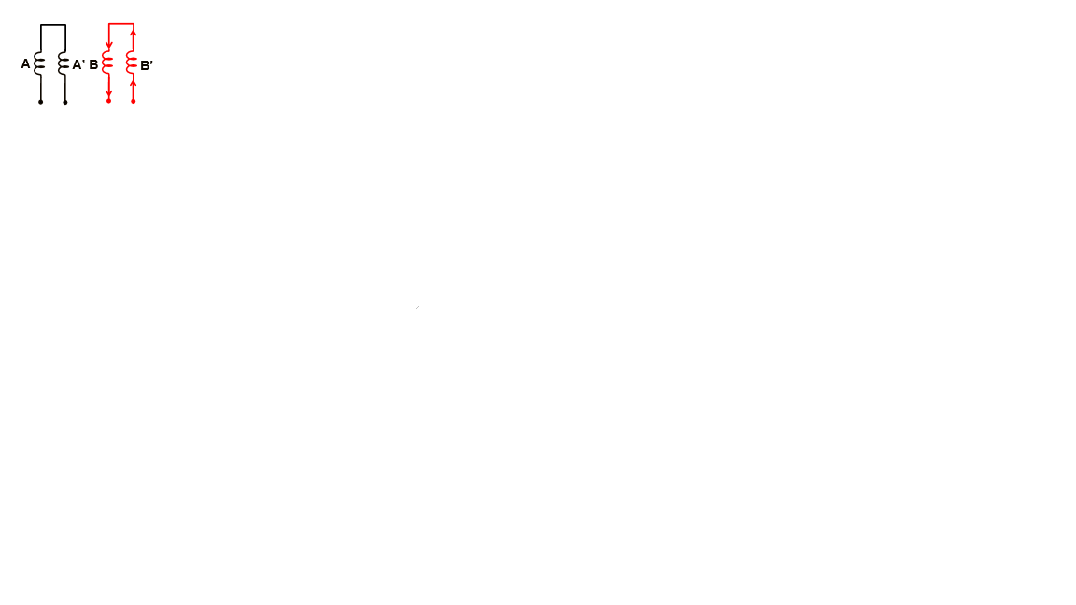 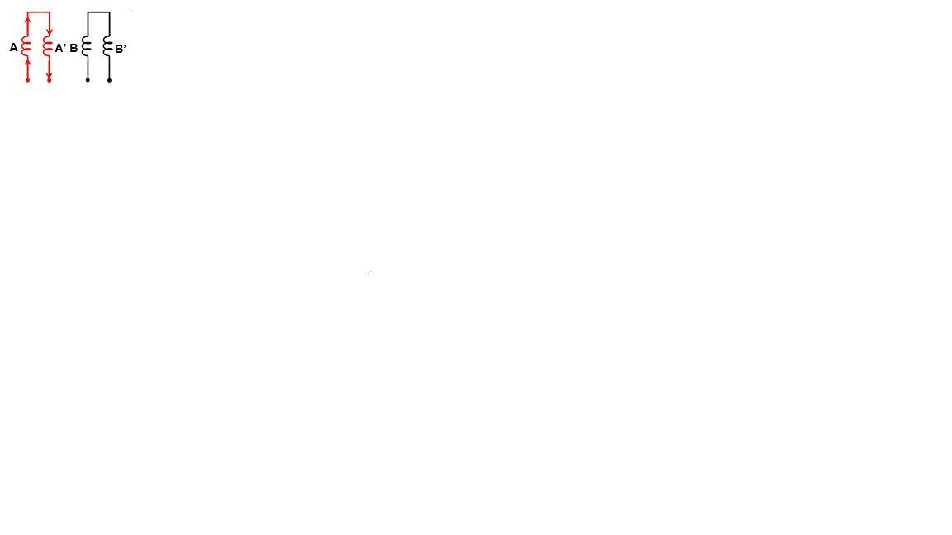

Variable Reluctance Motor

This type of motor, uses a rotor that is not magnetized, and has a number of teeth as seen in the image below. The windings are configured differently, as depicted in the second figure, all having a common voltage source but with each end being separate. They usually have 3 or 5 windings. Greater precision can be achieved by adding more teeth to the rotor.

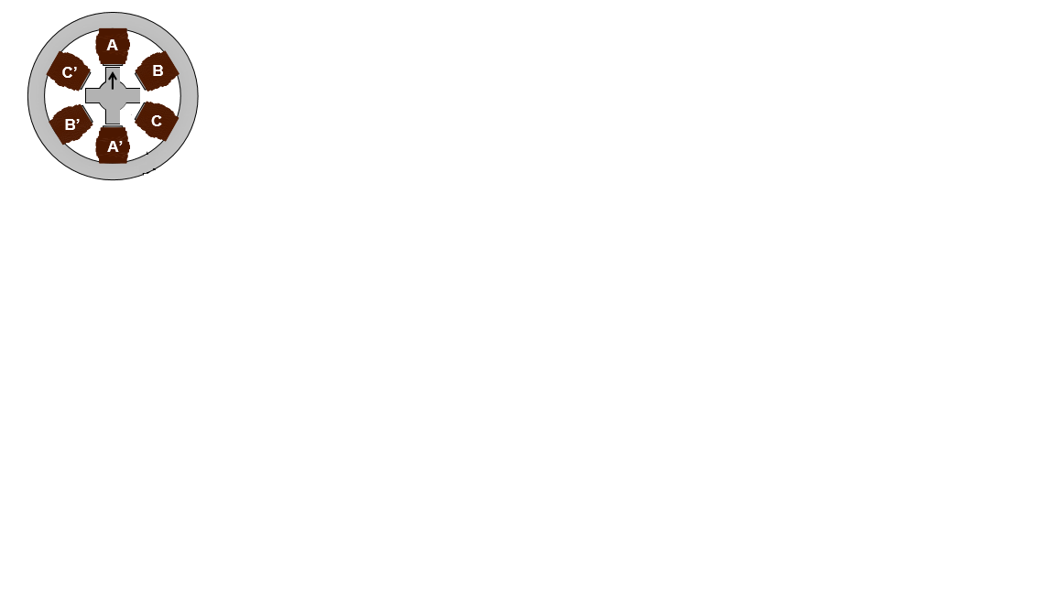 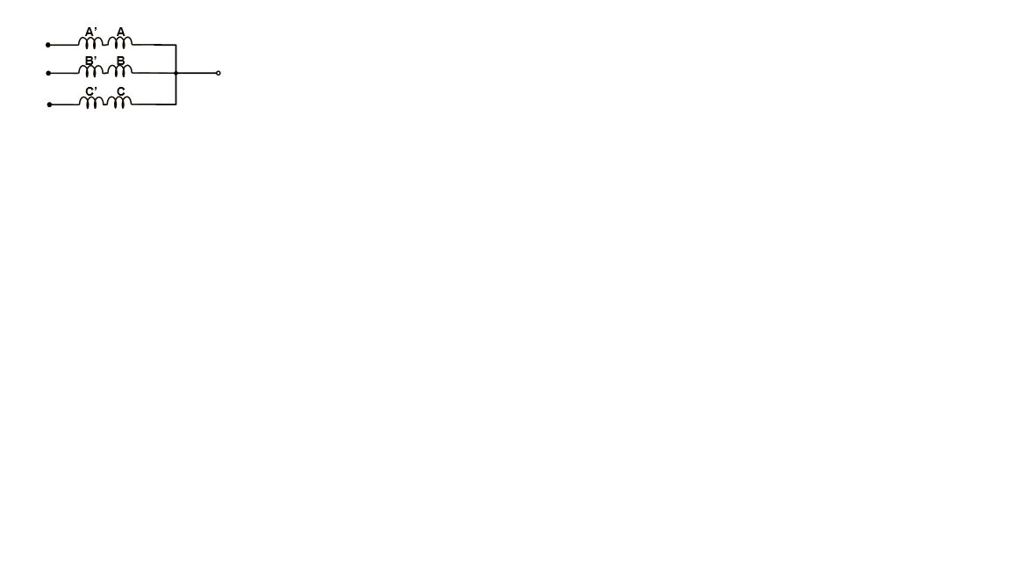

To spin the motor, each winding is energized one at a time, and the rotor rotates in such a way, to minimize reluctance. Some of the differences, between this type of stepper motor and the permanent magnet motor, are that, in order to spin the motor in a direction, the windings have to be energized in a reverse sequence, as depicted in the images below. In addition, the step angle is actually half of the one of a permanent magnet motor with the sam number of windings is.

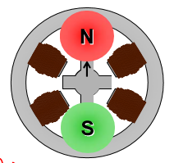 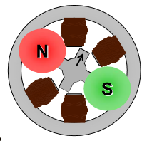

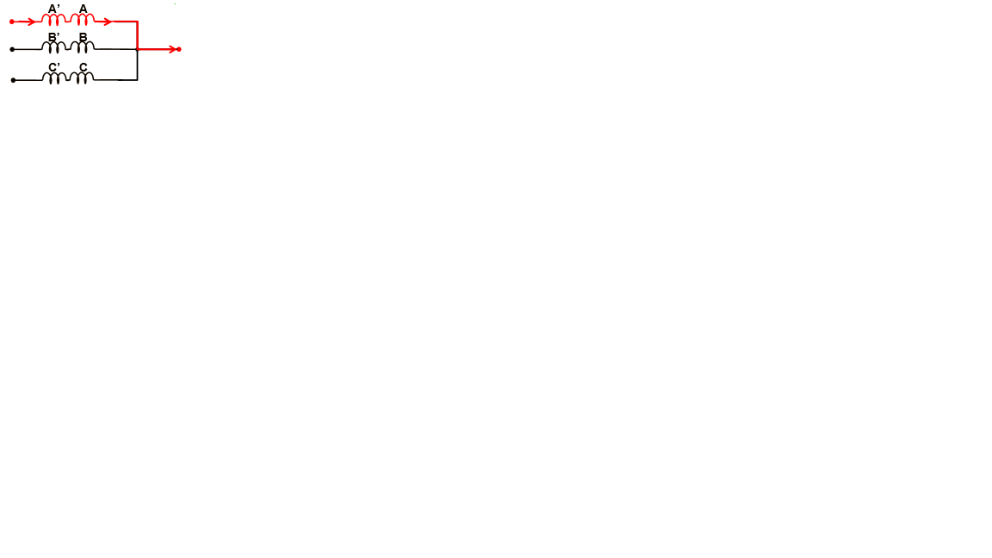 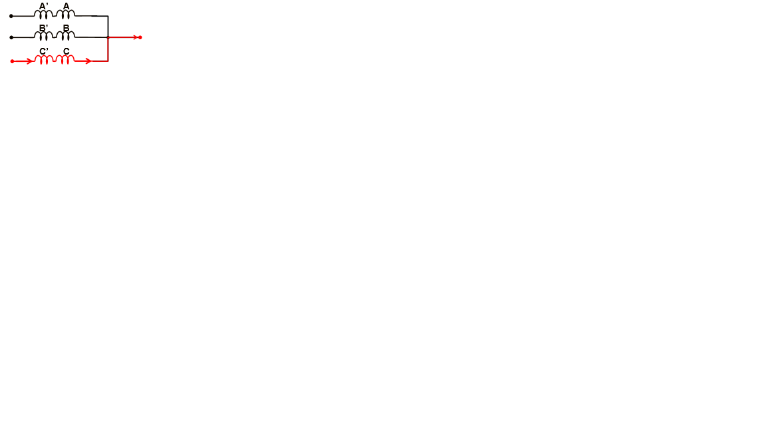

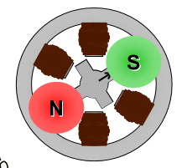 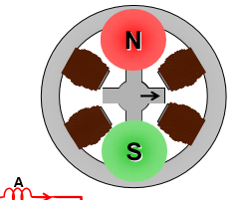

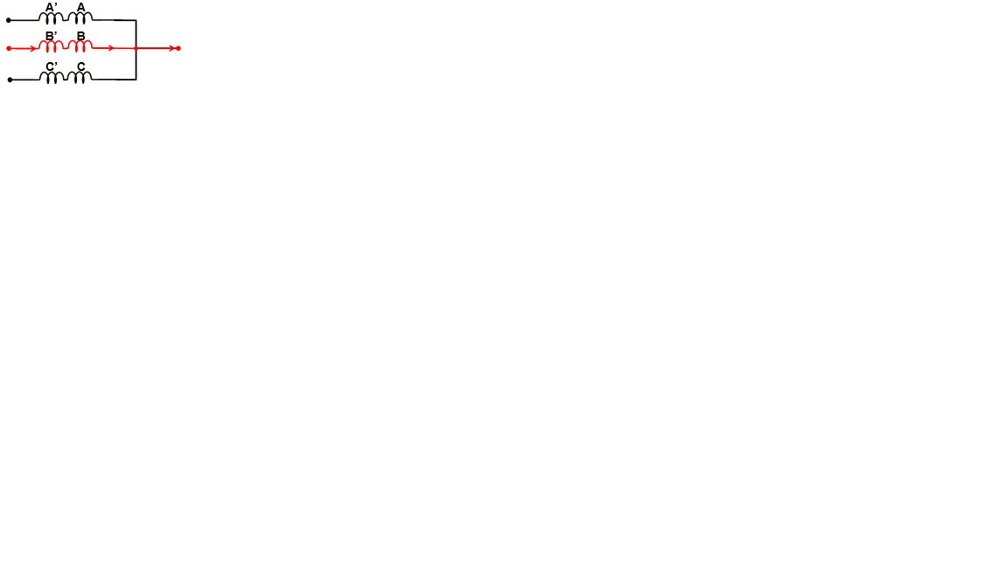 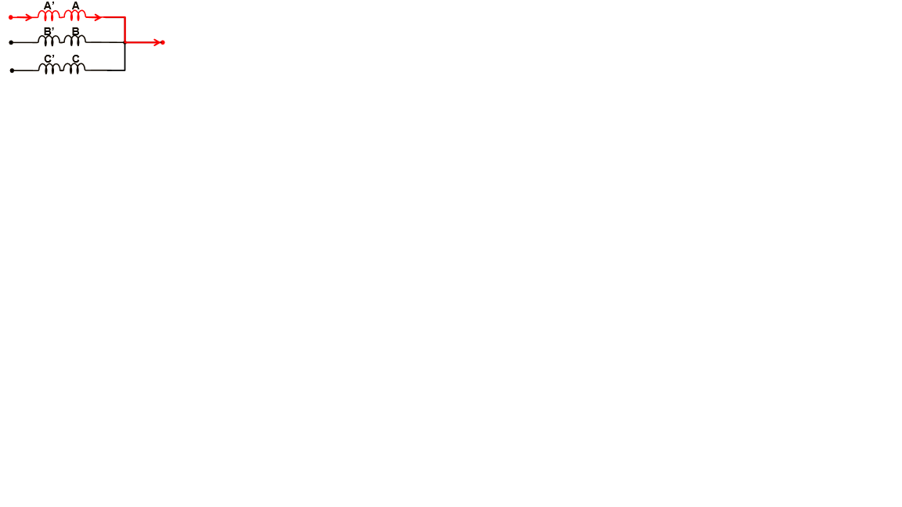

Hybrid Stepper Motor

Hybrid stepper motors borrow characteristics both the previous ones. The picture below shows the two of the main components of the hybrid stepper motor. On the left side, the stator can be seen consisting of 8 poles. On the right side, is represented the rotor. The rotor consists of two sets of teeth, corresponding for the two poles, north and south, respectively.

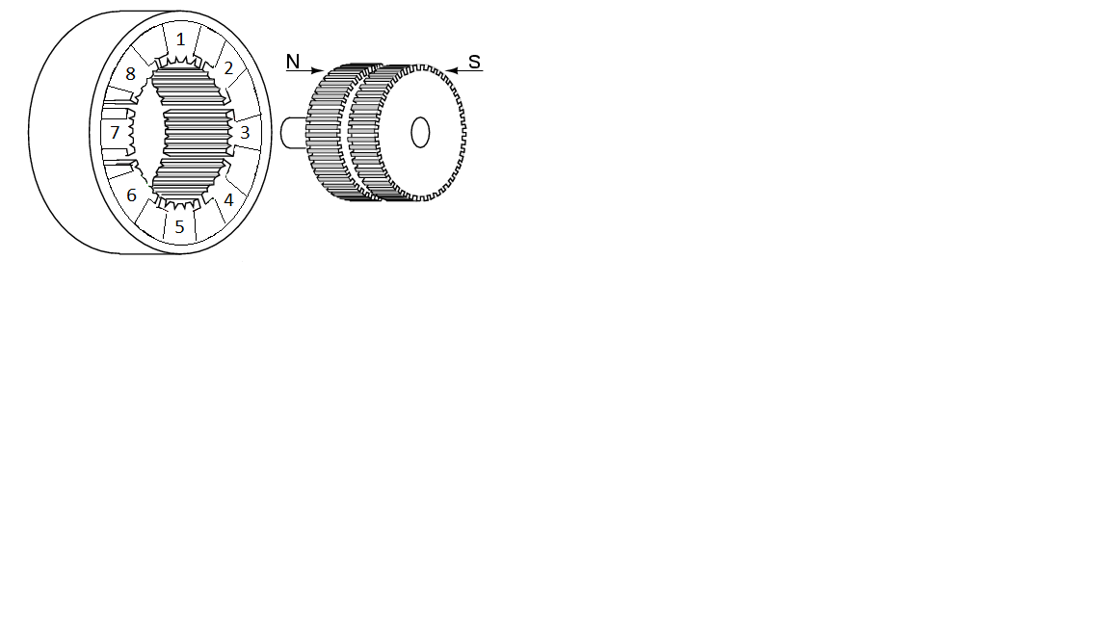

It is important to notice two additional things. The first, is that the teeth on the rotor are not aligned but are interleaved, as shown in the picture below. The second, is the placement of the stator teeth in respect to those of the rotor, represented in the second picture.

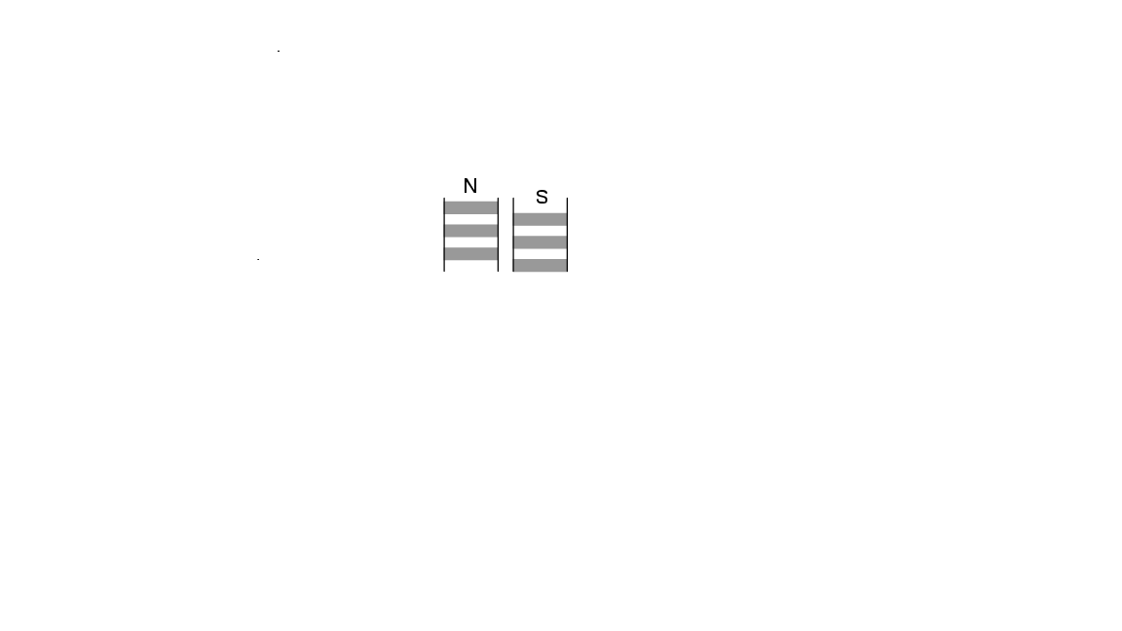 [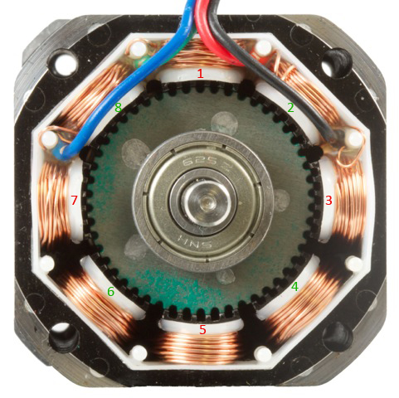](https://www.google.dk/url?sa=i&rct=j&q=&esrc=s&source=images&cd=&cad=rja&uact=8&ved=0ahUKEwiu1unxnobXAhViYZoKHVNDAH0QjRwIBw&url=https://www.phidgets.com/docs21/Stepper_Motor_and_Controller_Primer&psig=AOvVaw3cz5PfXM_5bzk9u1YA1zaw&ust=1508830748376703)

It can be observed in the second picture, the windings with numbers 1 and 5 are completely aligned with the teeth of the rotor. Windings number 3 and 7 are completely unaligned, while the others are half aligned. This results in higher precision and higher torque offered by the hybrid stepper motor, depending on the stepping method used.

The picture below represents the front view of the hybrid stepper motor together with the configuration of the two windings.

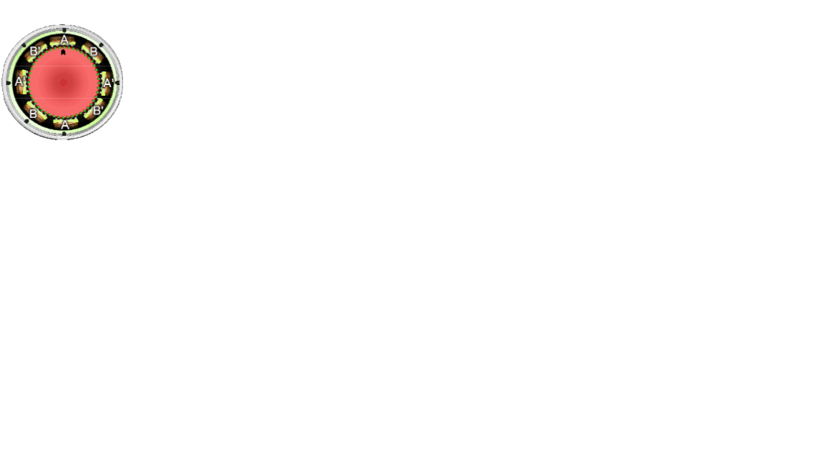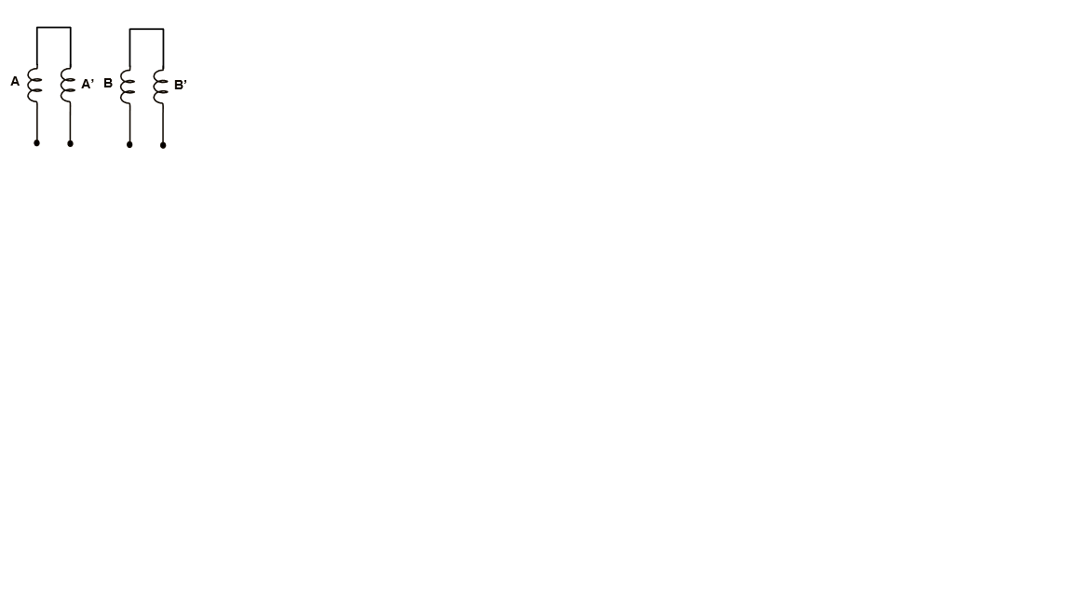

It is important to notice that, even though the motor has only two windings, each individual winding energizes 4 stator poles.

The pictures below represent the way this motor operates.

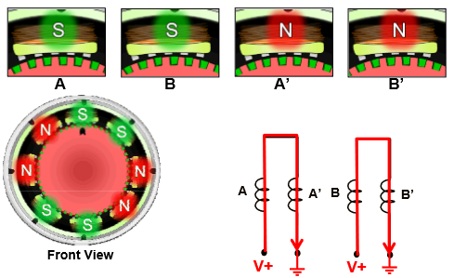

By applying a voltage to both windings, the current flow can be controlled, thereby controlling the polarity of each stator pole, thus controlling the direction of the motor. Notice that, initially, poles A and A’ are completely aligned, and poles B and B’ are half aligned.

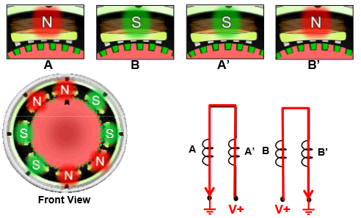

Next step involves changing the direction of the current in winding A by applying a voltage at the other end of the winding. Even though only the current in winding A has been changed, all stator poles are aligned differently. Poles A and A’ are now half aligned, and poles B and B’ are completely aligned.

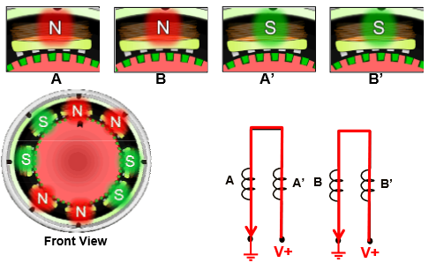

Now, changing the direction of the current in winding B, changes the polarity of the stator poles B and B', again, determining a change in the alignment of all stator poles. A and A’ are now completely aligned, and stator poles B and B’ are half aligned. The positions of the stator poles now correspond to those of the first step.

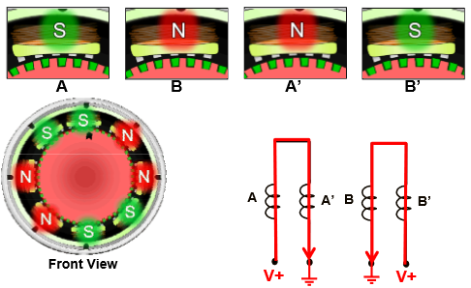

Finally, again changing the direction of the current in winding A, determines the rotor to move another step. Notice the alignment of the stator poles. A and A’ are half aligned, while B and B’ are fully aligned. By changing the direction of the current in winding B, the motor arrives in the initial state, thus repeating the sequence.

Unipolar and Bipolar Stepper Motors

Another classification of stepper motors, is depending on the way the windings are configurated. Even though, nowadays, almost every stepper is both. Meaning that unipolar and bipolar, are rather modes in which the stepper motor can be driven. Exception being, stepper motors which have only four wires coming out of them, corresponding to bipolar stepper motors.

The pictures below represent the configuration of the windings in both unipolar and bipolar stepper motors.

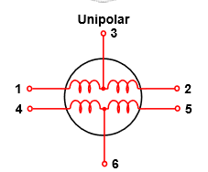 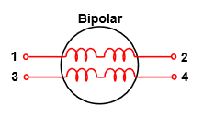

Unipolar stepper motors allow current flow in only one direction through the winding, so a center wire has been added, that provides a voltage and determines the stator poles do either be of north or south polarity. Unipolar stepper motors are widely used in applications that require high torque at high speed.

Bipolar stepper motors, allow current to flow in both directions through the windings, so the need of a center wire to provide a voltage disappears. However, the circuit needed to drive a bipolar stepper motor is more complicated. Bipolar stepper motors driving boards exist to make it easier for a person to program the motor. Bipolar stepper motors are used in applications that require high torque at low speeds.

The pictures below are intended to better explain the operating method of both types of stepper motors.

Unipolar Stepper Motor

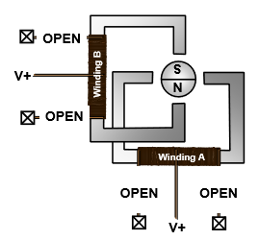 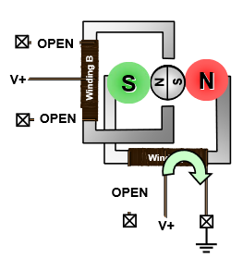

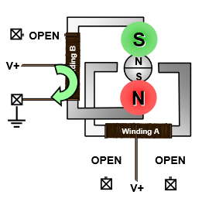 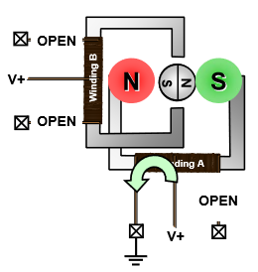

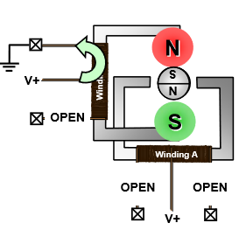

As seen in the pictures above, each step only uses half of the winding, determining the polarity of the stator poles. The voltage is always applied at the same wire two wires.

Bipolar Stepper Motor

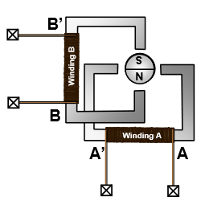 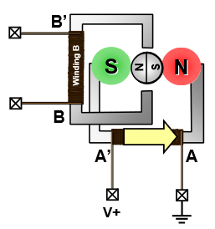

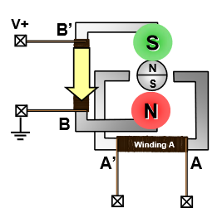 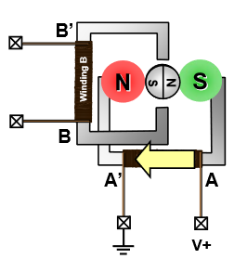

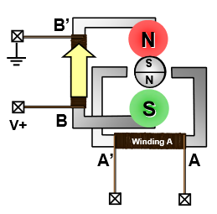

Note that the bipolar configuration allows the current to flow in both directions, but the voltage and ground continuously switch positions. This makes bipolar stepper motors a bit more complicated to drive, but as previously stated, motor driver boards simplify the task.